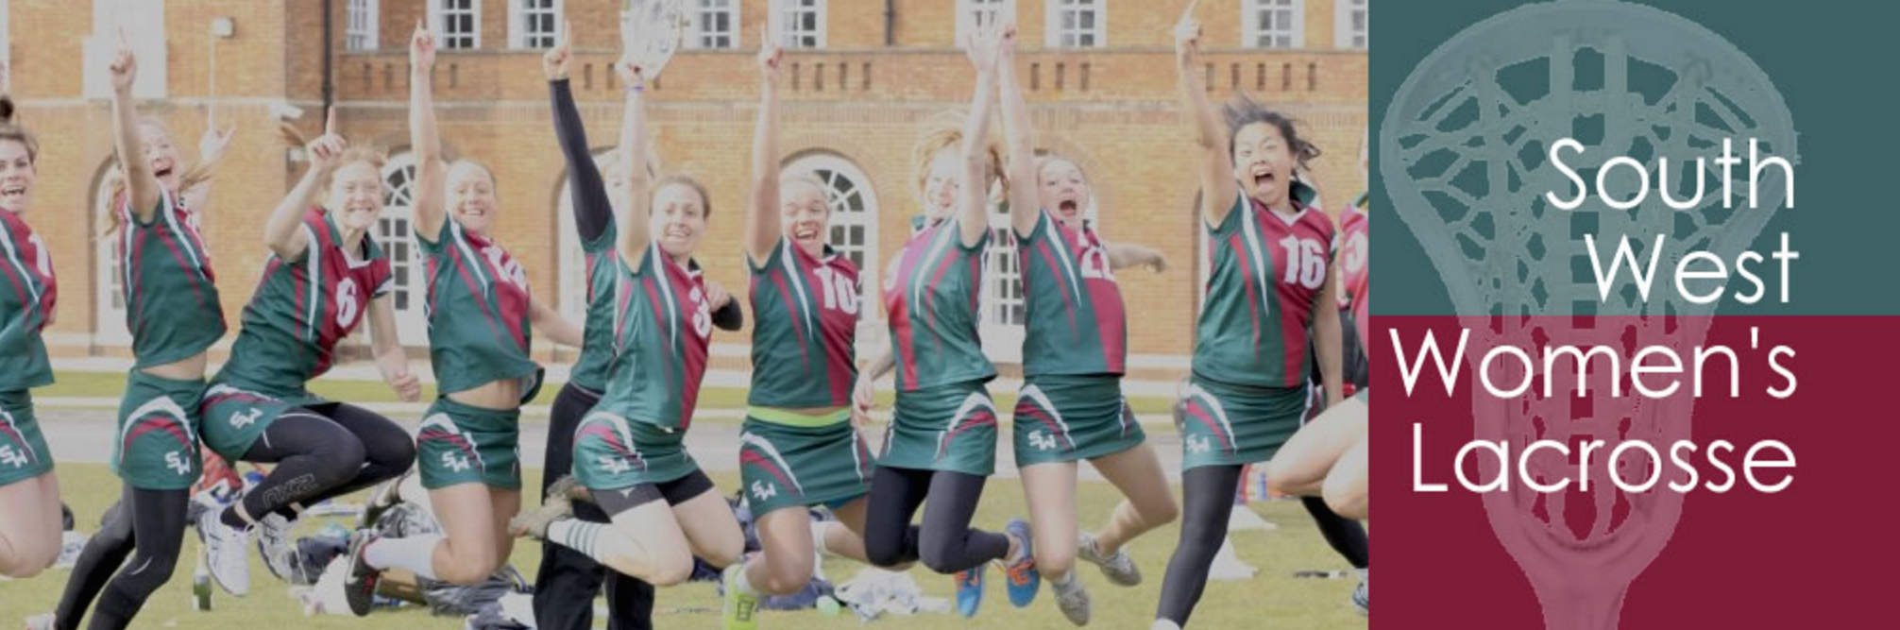

South West Committee Away Day - Minutes

Monday, 28th September 2020 9.00 – 12.00

The Square by Coffee Lab, Winchester

Present: Heidi Marvin (HM), Chloe Watterston (CW), Kate Nelson-Lee (KNL), Michele Bray (MB), Victoria Westwood (VW)

|  |  |  |
| --- | --- | --- |
|  |  | Action by: |
| 1 | Apologies for absence: Helen Amos, Sally Keogh, Clare Stoots |  |
| 2 | Minutes of last meeting: approved with amendments |  |
| 3 | Covid-19 Club Survey  Include survey to all universities in the SW  Add reminder to clubs to pay on Covid-19 survey | VW  VW  VW |
| 4 | NCL Update from 9.9.202  KNL unable to attend and hasn’t yet received minutes; normal process of reviewing committees discussed  HW+KNL had attended Women’s Events zoom: Stick with current rota so SW organizing Super Counties, not regionals;  Super counties and regionals meant to be self-financing |  |
| 5 | Senior Regionals  Selection of Coaches – coach at SW CofE as part of selection process; give clear indication of what we expect/feedback from previous year – from Chair; selected coaches to go to League tournaments to watch/encourage players to attend trials  Add a layer of Selectors of players – adapt Super Counties job description?  Eligibility – set nationally for representational teams; need to improve our cohesion – do players have a real tie with the region;  What is the function of the B team? Focus on development in coach’s job description  Aim is to improve standard of performance in SW and opportunity for aspirational players  Establish a SW Centre of Excellence  Encourage SW undergraduates to participate  B team marginals to feel more worthy of consideration, that trials are more ‘open’  CofE day – training am, game play pm; in order to come, have to play for SW club, be a SW university undergraduate, or aspiring to play Senior SW regionals (with suitable eligibility)  Ash Gloster coach?  Cost it up and decide whether to charge participants  Engage gap year students  Encourage uni coaches to go  2021 October, November, 2022 January; geographically spread over region – Winchester (KNL), Bristol (Martha)?  **Action**: April 2021 set dates and venues for CofE days, recruit coaches, advertise – Ash, Raj etc | HM – VW try to find old job description |
| 6 | Super Counties  Advert has gone up on Instagram for Super Counties manager  Makkie happy to do again  Format for future; how to attract top level girls?  Has become ‘whoever wants to do it’, don’t need staff nomination ie girls ‘opt-in’ (or not); low take up of National Academy girls, especially older years  HW discussion with North – they would prefer to put out old style county winners; they have been running old system alongside Super Counties; current system good for developing girls who aren’t in Academies but want better lacrosse  Operational changes/improvements – year 4 in SE, year 3 in SW, year 2 in N – have been hiccups so still need structure to bed down fully; coaches/schools need to promote/support; don’t need a training day – clashes with too many other commitments so badly attended; ½ day training, 1 ½ day matches?  Send winning team with starred players from other teams used as reserves as necessary  KNL/HM Schools meeting 8th October – decide when and if to go ahead; keep as ‘Super Counties’ | KNL/HM |
| 7 | Senior League  Check list of registered players with Kerrie Lawler for this season’s matches  Add reminder to clubs to pay on Covid-19 survey  At Chairs’ meeting, talk about regional boundaries being observed by participating teams? Would mean their players would also qualify for SW Regionals; help SW in general   * Reading Wildcats? Newbury Royals? Encourage them or their 2nds participate in SW   Keep current structure for next season  Development tournaments worked well – 2 is plenty  Venue: try to find alternative to Westonbirt: Beversbrook? Kevin Whitehorn HM details to VW; revisit notes from Clubs’ meeting last Spring  Ask Cassie Allen EL for help/support  Development at Westonbirt? Premier elsewhere?  Junior? Nothing at the moment as Tribe participate in SW; talk by Nik Roberts of a junior Cotswold League being created? | VW  VW  HM  CW/HM  HM/VW  VW  VW |
| 8 | 6v6 Playground to Podium  CW did 6s at QAS, girls loved it  HM on Regional Chairs webinar this week with Mark Coups  SW needs to know which schools etc in our area are being targeted; needs to be cohesion between new hubs and region/clubs/schools outreach  Need greater clarification of rules  What specific help do EL expect from the regions? | HM |
| 9 | Relationship with other Regions  HM meeting Alex Waterman SE Chair in webinar 28.9.20   * ask his feeling re teams from SW region playing SE | HM |
| 10 | ‘Regional Development Officer’/Education Officer  NLC: request greater cohesion/insight between EL education/development to regions to help regional outreach | KNL |
| 11 | Retention of school leavers/late comers  EL/SW needs to have some way of getting into schools to spread details to school leavers; better done through coms/schools committee/ publicity at national schools etc  Handbook with all club/uni/sw info – how to keep playing after school options  Money from lacrosse foundation to support  Umpiring tuition in schools  Flag up opportunities to earn money: umpiring at uni + coach at junior counties KNL to put to NLC  HM at school meeting encourage teachers to promote links  HM talk to Charlotte Williams and Becs Gaunt  VW share link to Graduate Handbook  Encourage leavers to make links with local clubs before uni/during holidays | VW/HM  KNL  HM  HM  VW |
| 12 | Any other business  Request greater clarification from EL re variety of rules/types of games  CW now an administrator on SW Umpiring FB page  Social media administrator –ask Lydia Nicholson at Cheltenham  ULO – VW get list from Casey Allen onto website  Put university contacts onto website + Teams | VW  VW(KNL)  VW |
| 13 | Date of next meeting:  Thursday, 19th November 2020 19.45 via Teams | KNL |