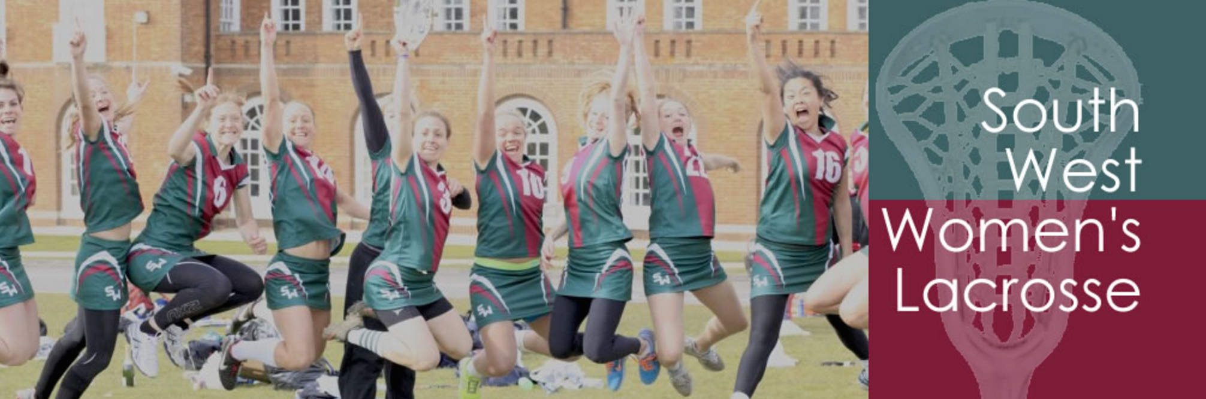

South West Committee Meeting

Minutes

**Thursday 22nd November 2018**

**7.30pm @ Fox and Goose – Coombe Bisset, Salisbury**

Attendees: HA, KNL, MB, CS, EF

Apologies: JM, SK, EC, IM, BO, PJ

Minutes of last meeting – all agreed

* Senior League (update from BO)
  + Positive response from PJ attendance and umpire clinic at previous tournament – PJ to attend tournament on 25th Nov
  + Cheltenham issued poor conduct warning – a general feeling that attitudes towards umpires is poor – how can we improve umpiring and attitudes in senior league?
    - Add code of conduct to bottom of all emails sent (BO & IM)
    - Mention code of conduct and expected behavior at beginning of tournaments
    - Add EL respect code (or a tweaked version of it) to website (EF)
  + Encourage university teams to enter SW league – can play in two tournaments without having to commit to league – a good opportunity for university players to see how senior league works and encourage them to join a club once graduated
  + Dates for 2019/20 season: 29th September too early, will be pushed back to 6th Oct. Potentially run a ‘get your game on’ session on 22nd September with opportunities for players and also an umpire clinic
    - Dates set for tournaments: 6th Oct, 27th Oct, 24th Nov, 9th Feb, 1st March and 29th March. Indoor tournament on weekend of 18th/19th Jan
  + New league sec – an administrative role. From January, need to start asking/advertising position. Could offer a £200 stipend to appointed individual as incentive
  + Westonbirt have indicated that fees may alter for upcoming season – we should come to an agreement and set a rate before providing further goals
  + Some teams are struggling for numbers – what can we do to help? Make teams aware of bursaries that are available and send an email to offer support.
* Senior Regionals
  + Need a comms push for more players to register (EF to promote online)
  + Increase England player participation – KNL to make aware of regionals at training day
  + Encourage club players to register at tournament on 25th Nov – Raj to attend if possible
  + HA emailed Raj and coaches with suggestions to avoid perception of Welsh team bias – make players aware at beginning of trials the coaches affiliation to Wales but to make it clear that this will not cause bias. Keep communication open
  + Senior Regionals will take place as a 2-day tournament – can be reviewed whether 3 trials/training sessions are required if tournament goes back to a 1-day tournament
* SuperCounties
  + Makkie Lowe has done a great job – logos, playing shirts and hoodies for players all received very well
  + Feedback from ML – 11/11 date not great attendance – this could be due to commitments for remembrance Sunday. Some staffing issues for 25th. 
    - Feedback from KNL – 11th Nov was really successful, 6 teams per age group. ML appointment may have been a bit late and so some issues with smooth handovers
  + Send an official thank you letter from South West to ML and ask if she would like to continue in the post for another year
  + Increase engagement of girls from non-independent schools
  + Umpire rates need to be considered
  + Run an umpire clinic on morning of first day next year, with umpiring in the afternoon
  + Tournament will be in the North with 2 teams per region/ per age group
  + EF to upload photos from Supercounties and publicize event
* Budget and Development fund update
  + Bristol University have sent invoice to South West and have been paid
  + There are 2 outstanding grants which must be spent by March
  + Make clubs aware of the bursaries that are available
* 2019/20 Budget
  + Refund league deposits after 3 years – these will be refunded this season
  + Review league fees for upcoming season at March committee meeting
  + Thanks to HA for budget – all approved
* AOB
  + KNL – financial discussion points for NLC – *can we get a copy from KNL to put in here (as an appendix) and what we decided?*
  + NLC away day decided on working groups as follows: Communications, Universities, Club development and Volunteering – KNL to ask participants from SW away day to attend a volunteering away day on 10th Feb and to discuss volunteering strategy update
  + Running a club away day to be organized – advice on best governance and practice
  + Umpire audit for the South West – set targets for how many umpires we want in the region and review
    - Could involve appointment of an umpire development administrator who would communicate with umpires and act as a mentor to umpires in the region
  + Committee positions – HA to email EC, JM and SK to ask if they still want to be on committee
  + Positions needed include an Umpire admin, a representative from Schools and a league sec – new appointments to be made by June.
  + *Suggested that 2 of these administrator positions include a £200 (or similar) stipend – League administrator & umpire development administrator.*

**Date of next meeting: Tuesday 12th March 2019**